3.56: The equations of motions are 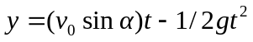 and 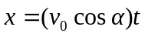, assuming the match starts out at 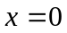 and 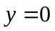. When the match goes in the wastebasket for the minimum velocity, 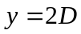 and 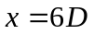. When the match goes in the wastebasket for the maximum velocity, and 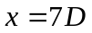. In both cases, 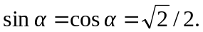.
To reach the minimum distance: 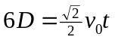, and 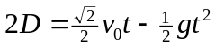. Solving the first equation for t gives 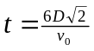. Substituting this into the second equation gives 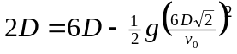. Solving this for  gives 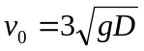.
To reach the maximum distance: 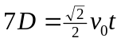, and 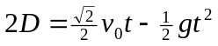. Solving the first equation for t gives 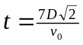. Substituting this into the second equation gives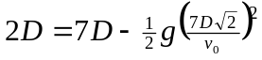. Solving this for gives 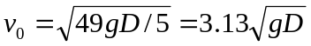, which, as expected, is larger than the previous result.

